Login: https://eeiz-test.fs.em3.oraclecloud.com/xmlpserver/servlet/catalog

(N)🡪/Shared Folders/Human Capital Management/Payroll/Regulatory and Tax Reporting/Emirates

Select “AE Payslip” and click on Customize

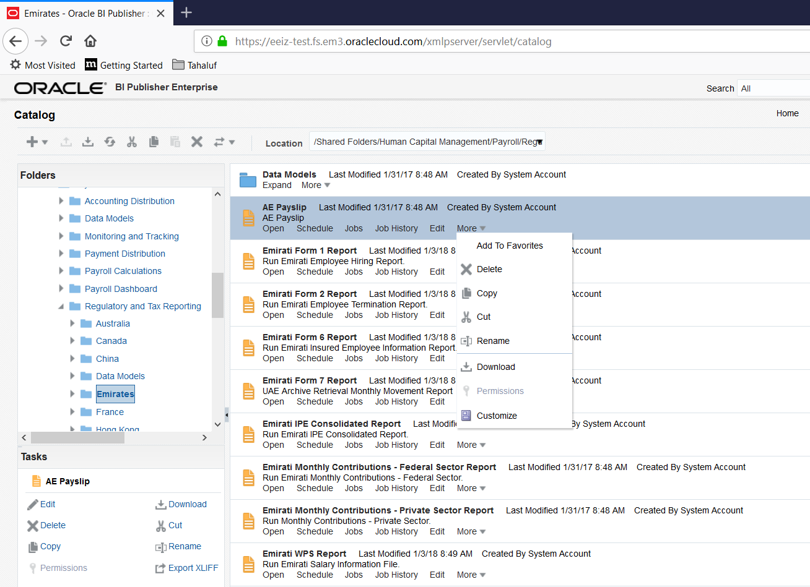

Click on Add New Layout

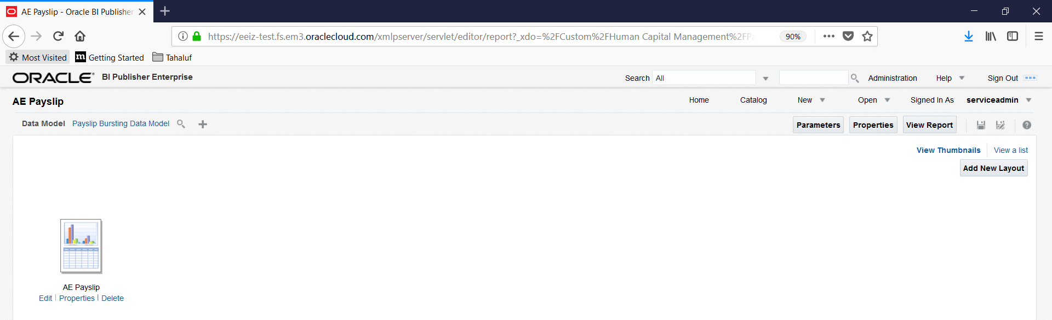

Upload the Customized Layout as shown below with the below screen shot values



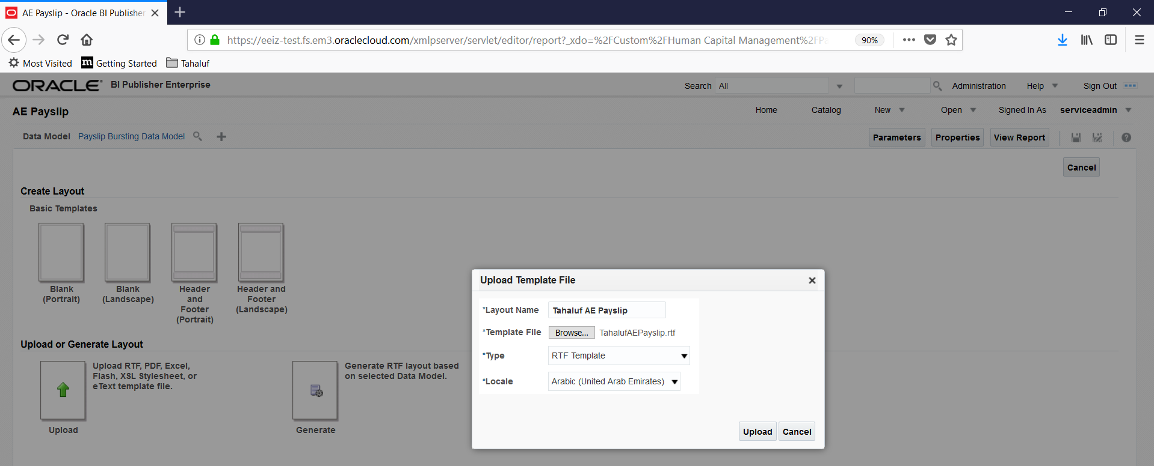

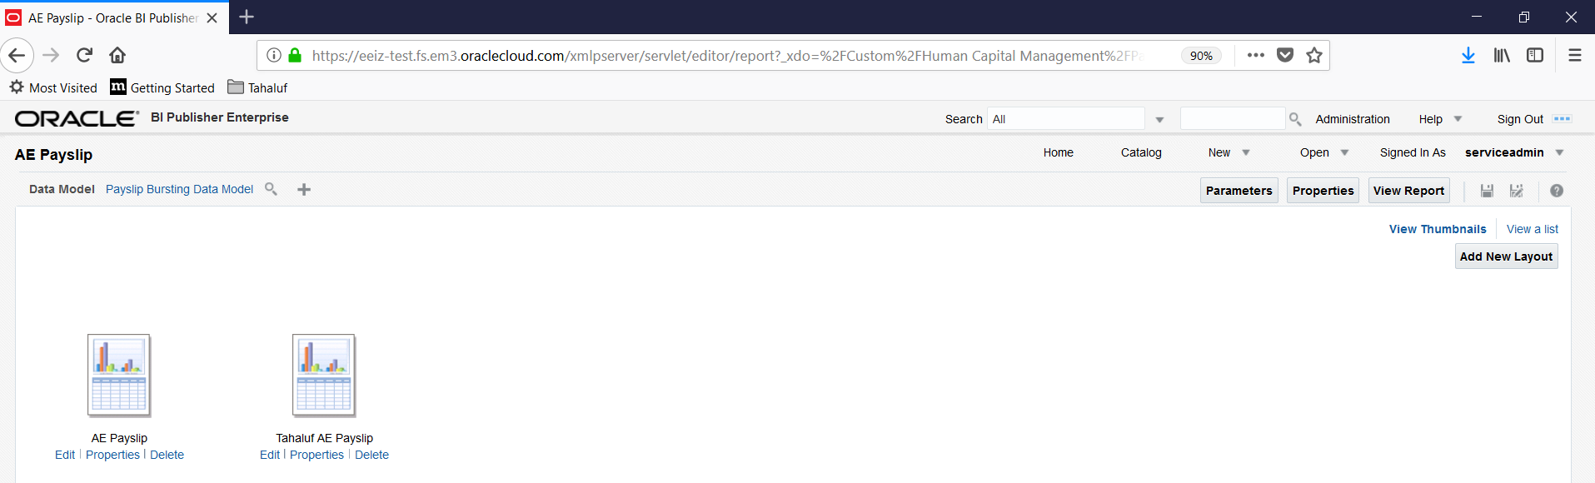

Click on View a List 🡪 Change the Default Format as “PDF” and “Default Layout

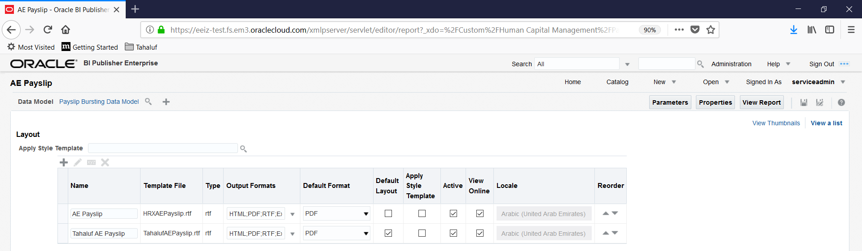

(N)🡪 Data Exchange 🡪Manage Extract Information

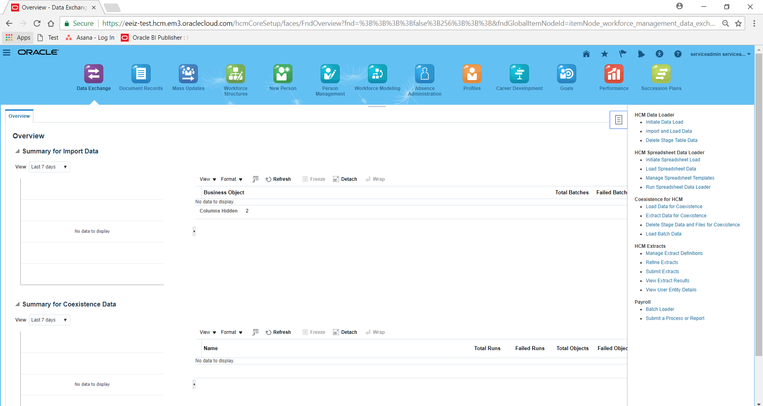

Search with Name “Payslip”, LDG “AE Legislative Data Group” and Type “Archive Retrieval”

Click on the Search Results “Payslip”

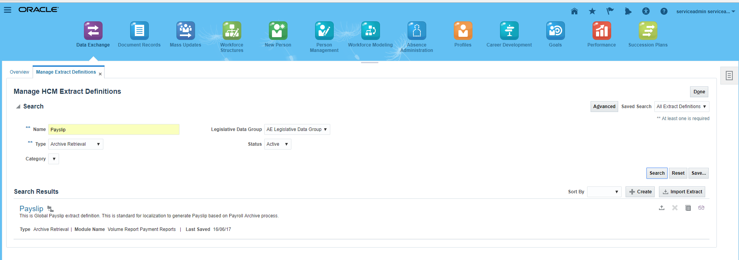

Click on “Deliver” then add Extract Delivery Options

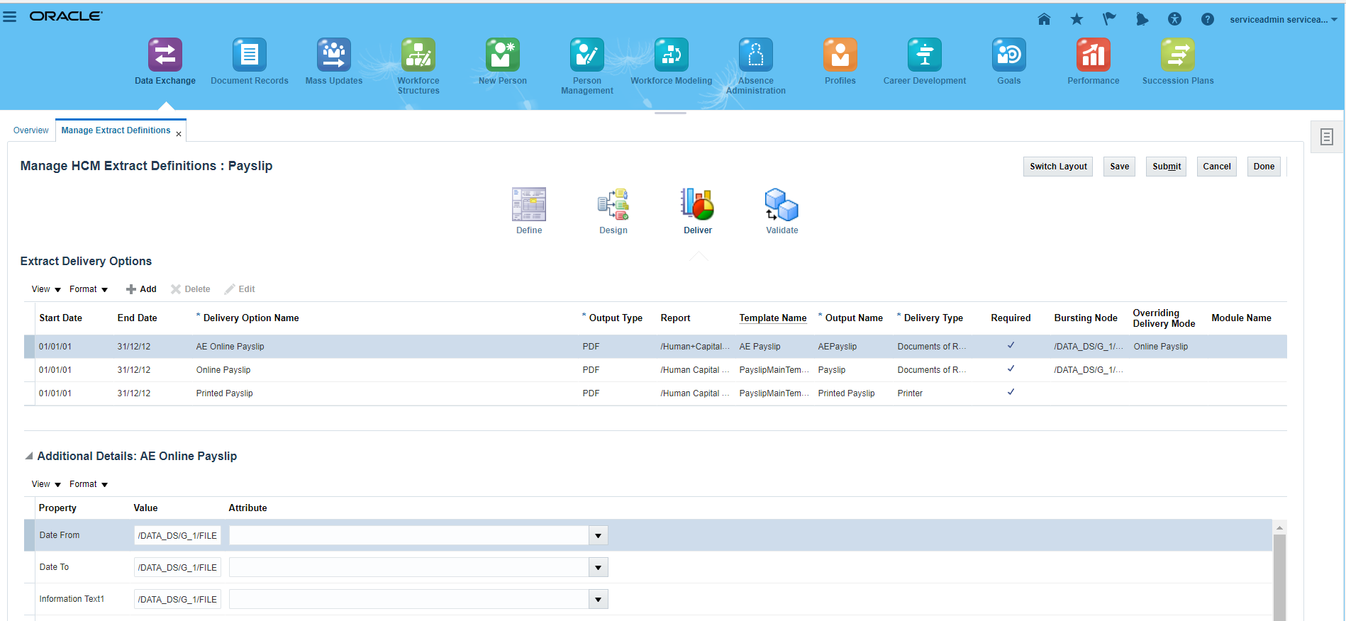

|  |  |
| --- | --- |
| Start Date | 01/01/1901 |
| End Date | 31/12/4712 |
| Delivery Option Name | Tahaluf AE Online Payslip |
| Output Type | PDF |
| Report (.xdo Name) | /Custom/Human Capital Management/Payroll/Regulatory and Tax Reporting/Emirates/AE Payslip.xdo |
| Template Name | Tahaluf AE Payslip |
| Output Name | Tahaluf Payslip |
| Delivery Type | Documents of Record |
| Required | Yes |
| Bursting Node | /DATA_DS/G_1/FILE_FRAGMENT/PAYSLIP/PAYMENT_RECORD/REL_ACTION_ID |
| Overriding Delivery Mode | AE Online Payslip |

After providing the above tabular values click on Save and Submit

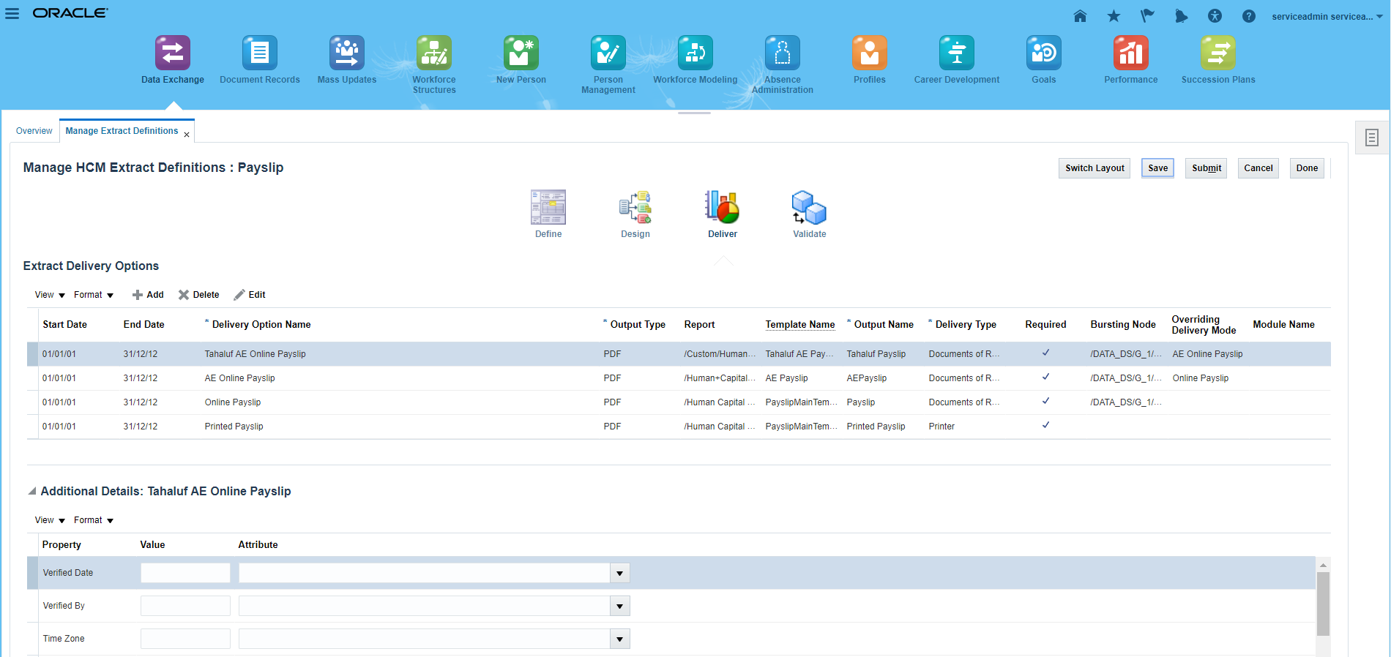

After on submit (System automatically calling the Validation) system shows the Validation Messages. Click on “Ok” to Proceed further steps.

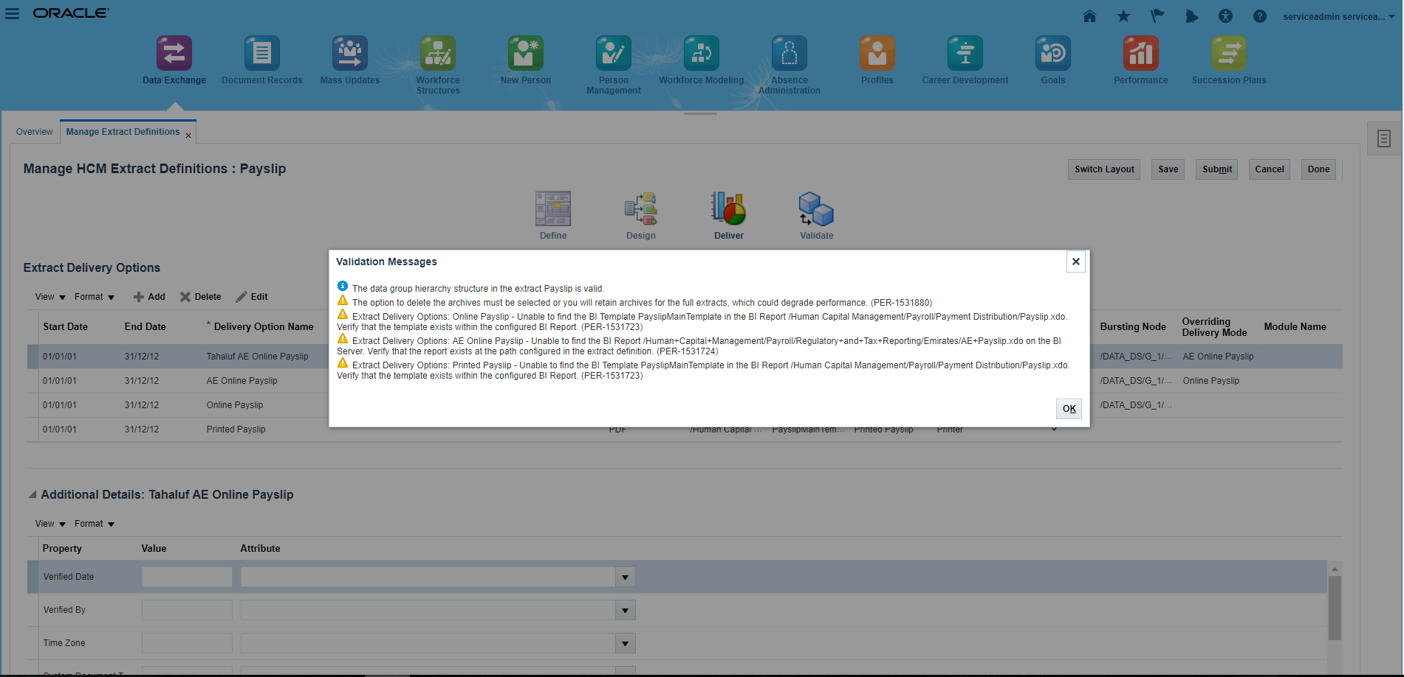

|  |  |
| --- | --- |
| Property | Value & Attribute for Key Values |
| Date From | /DATA_DS/G_1/FILE_FRAGMENT/PAYSLIP/PAYMENT_RECORD/GLB_ARCH_PR/GLB_PAY_ARCH_PR_PAYROLL/PAYROLL_PERIOD_START_DATE |
| Date To | /DATA_DS/G_1/FILE_FRAGMENT/PAYSLIP/PAYMENT_RECORD/GLB_ARCH_PR/GLB_PAY_ARCH_PR_PAYROLL/PAYROLL_PERIOD_END_DATE |
| Information Text1 | /DATA_DS/G_1/FILE_FRAGMENT/PAYSLIP/PAYMENT_RECORD/GLB_ARCH_PR/GLB_PAY_ARCH_EE_INFO/EMAIL_ADDRESS |
| Information Category | GLB_PAYSLIP |
| Information Date1 | /DATA_DS/G_1/FILE_FRAGMENT/PAYSLIP/PAYMENT_RECORD/GLB_ARCH_PR/GLB_PAY_ARCH_PR_PAYROLL/PAYROLL_PAYSLIP_VIEW_DATE |
| Information Number1 | /DATA_DS/G_1/FILE_FRAGMENT/PAYSLIP/PAYMENT_RECORD/GLB_ARCH_PR/GLB_PAY_ARCH_PR_PAYROLL/PAYROLL_ID |
| Information Number2 | /DATA_DS/G_1/FILE_FRAGMENT/PAYSLIP/PAYMENT_RECORD/GLB_ARCH_PR/GLB_PAY_ARCH_PR_PAYROLL/PAYROLL_PERIOD_NUMBER |
| Information Number3 | /DATA_DS/G_1/FILE_FRAGMENT/PAYSLIP/PAYMENT_RECORD/PAYMENT_DETAILS/PAYMENT_AMOUNT |
| Information Number4 |  |
| Information Number5 | /DATA_DS/G_1/FILE_FRAGMENT/PAYSLIP/PAYMENT_RECORD/GLB_ARCH_PR/GLB_PAY_ARCH_PR_INFO/GLB_ARCH_CBID/GLB_PAY_ARCH_CBID_INFORMATION/PREPAYMENT_RELATIONSHIP_ACTION_ID |
| Information Number6 | /DATA_DS/G_1/FILE_FRAGMENT/PAYSLIP/PAYMENT_RECORD/GLB_ARCH_PR/GLB_PAY_ARCH_PR_INFO/GLB_ARCH_CBID/GLB_PAY_ARCH_CBID_INFORMATION/CALC_BREAKDOWN_ID |
| Information Number7 |  |
| Document Name | PAYSLIP |
| Issued Date | /DATA_DS/G_1/FILE_FRAGMENT/PAYSLIP/PAYMENT_RECORD/PAYMENT_DETAILS/PAYMENT_DATE |
| Key | Add entry in Data Element after giving following values in the search region: -  Parent Data Group: - Global Archive Payroll Calc Breakdown  Date Element (Attribute): - Calculation Breakdown Identifier  Extract record (Record): - Global CBID Information |
| Locale |  |
| Person Id | /DATA_DS/G_1/FILE_FRAGMENT/PAYSLIP/PAYMENT_RECORD/GLB_ARCH_PR/GLB_PAY_ARCH_EE_INFO/PERSON_ID |
| Related Object Id | /DATA_DS/G_1/FILE_FRAGMENT/PAYSLIP/PAYMENT_RECORD/REL_ACTION_ID |
| Related Object Id Col | PAYROLL_REL_ACTION_ID |
| Related Object Name | PAY_PAYROLL_REL_ACTIONS |
| System Document Type | GLB_PAYSLIP |
| Time Zone |  |

Values are Pasted for the References as shown below

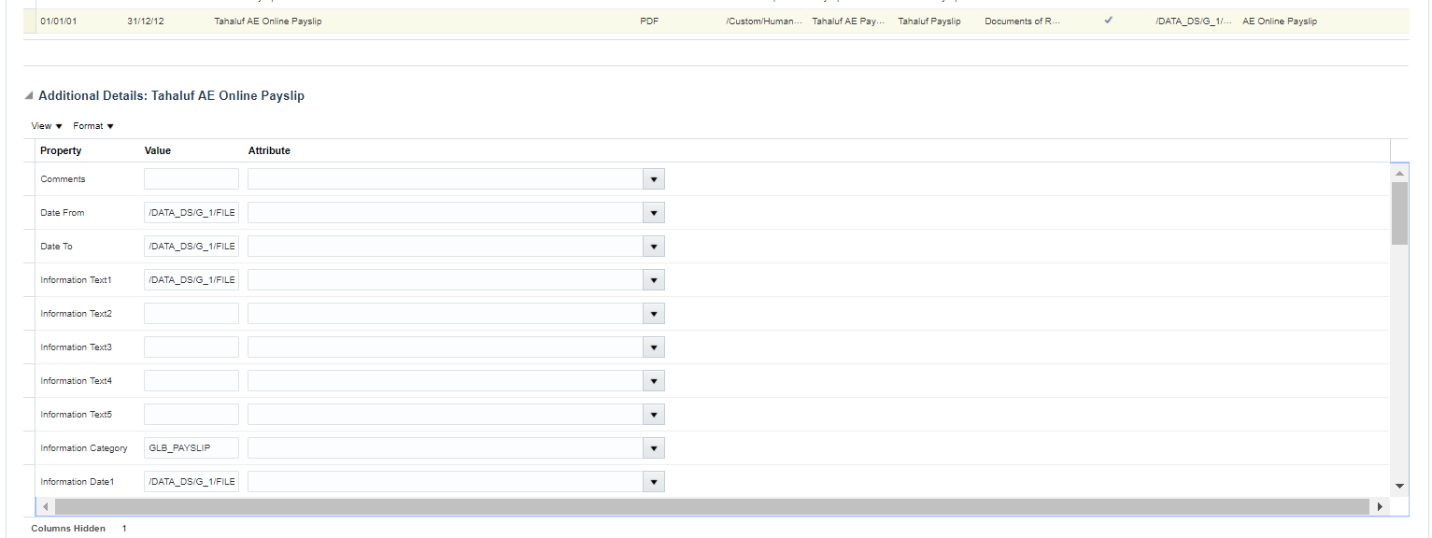

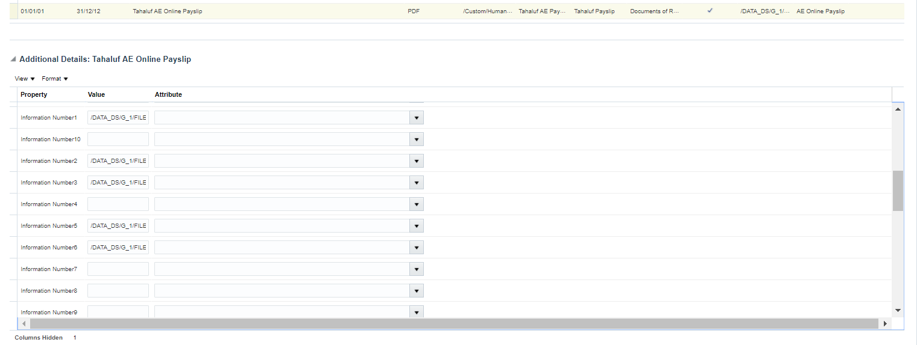

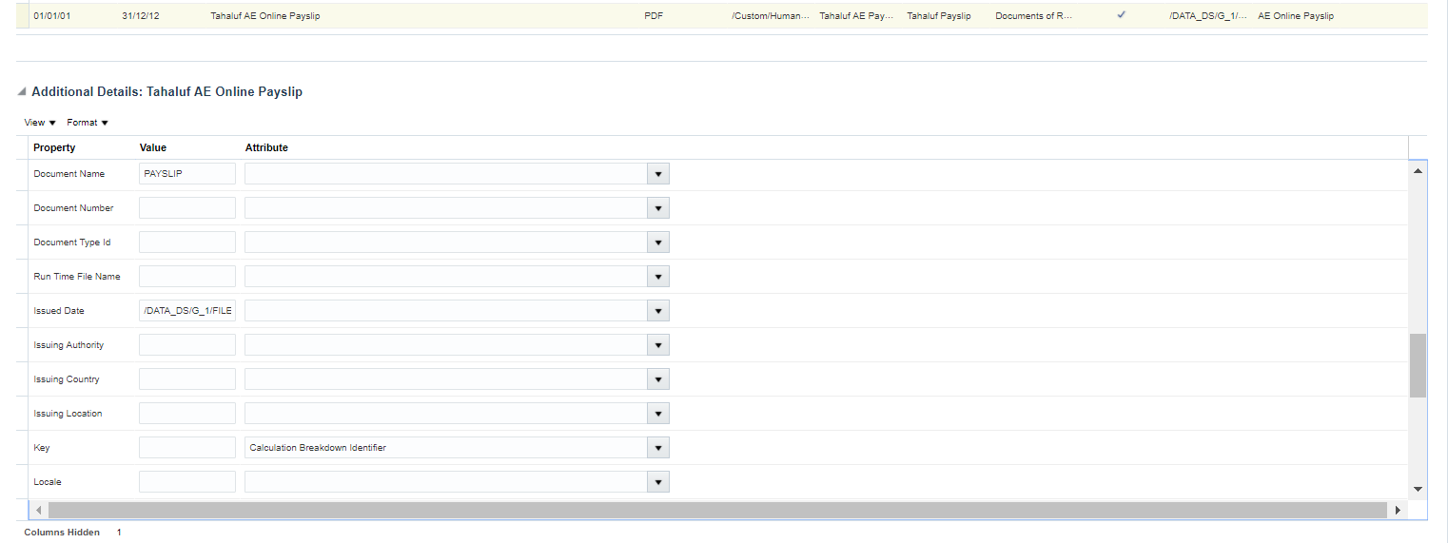

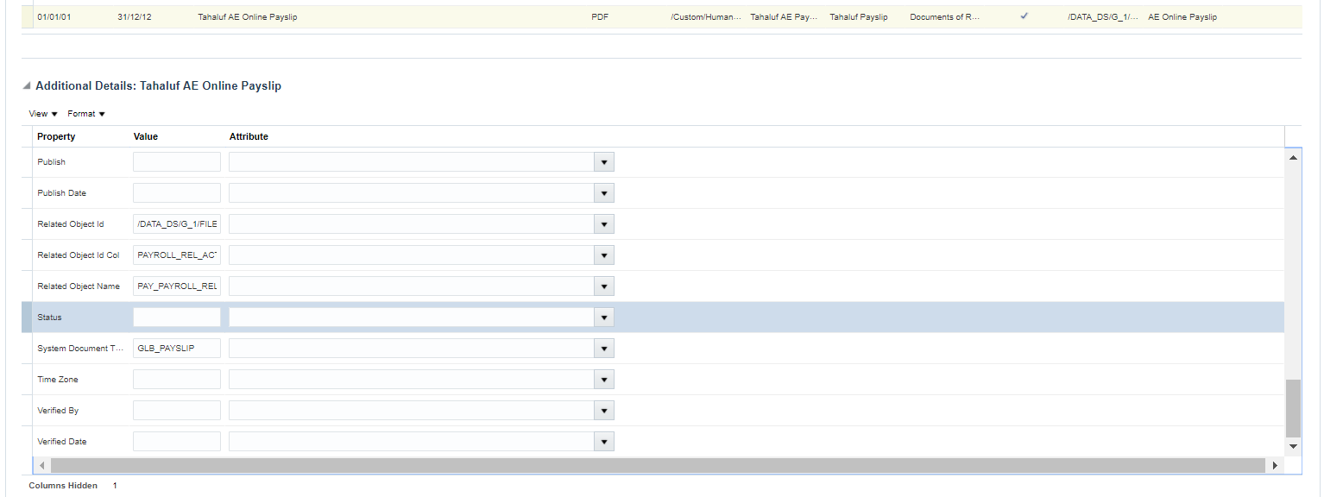

Click on Save and Submit